CASE FILE 09
Marquee Cinemas
Product line: monthly movie passes
Marquee Cinemas runs four movie theaters around Chicagoland. To compete with streaming, Marquee is launching monthly passes and wants a different pass for each kind of moviegoer.
Your job: Build a lineup of three versions, one for each segment below. For every version, choose its features and set its price. Your goal is the most total profit across all three.
THE MARKET: THREE SEGMENTS
Marquee Cinemas surveyed people in the Chicago area. The survey split them into three groups. Read the profiles, then give each segment a name.
SEGMENT A  15,000 potential customers | SEGMENT B  9,000 potential customers | SEGMENT C  3,000 potential customers
- Ages 13 to 22, goes with a group of friends  - Sees 2 to 4 movies a month  - On a tight budget, loves concessions  “Fridays are movie night. Every Friday.” | - Parents with 2 or more kids under 13  - Goes about twice a month, usually weekends  - Spends the most on tickets for the whole group  “Taking a family of five to the movies costs a fortune.” | - Ages 20 to 45, sees every major release  - Follows release dates and fan theories online  - Will drive farther for the best screen  “If it's not IMAX, why did I leave the house?”
Our name for them: | Our name for them: | Our name for them:
PRODUCT BASICS
Base cost of every version | $6 per member per month, before any features are added
Price options | $8 $12 $16 $22 $28 $38 (each version must use one of these prices)
WARM-UP: READ THE DATA FIRST
1. Which segment has the most must-have features (60% or higher)? How many does it have?

2. What is the most expensive feature on the menu? Which segment, if any, says it is a must-have?

3. What is the lowest price at which fewer than half of Segment B would buy?

4. If Marquee Cinemas sold a version with a Fit of 100% to Segment A at $16, how many people would buy it?

SURVEY RESULTS: WHAT EACH SEGMENT REQUIRES
Question asked: “Which of these would a monthly movie pass need to have before you would buy it?”
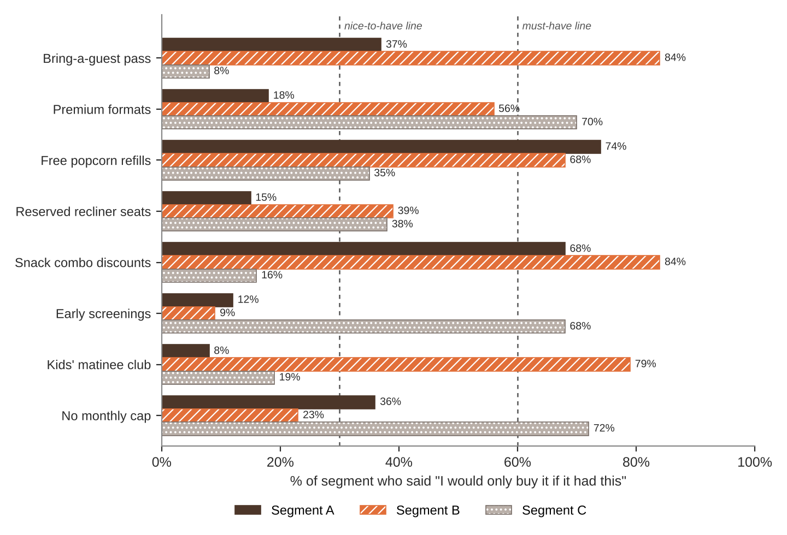
FEATURE MENU
Every feature you add raises your cost per member per month. Add a feature to any version you want.
Feature | What it is | Cost to add
Bring-a-guest pass | One free guest ticket each month | $4
Premium formats | IMAX and 3D shows included | $5
Free popcorn refills | Unlimited refills on any popcorn | $1.50
Reserved recliner seats | Pick your seat when you buy | $2
Snack combo discounts | 20% off snack combos | $1
Early screenings | See big movies the night before | $3
Kids' matinee club | Saturday morning kids' movies | $1
No monthly cap | Unlimited movies instead of 3 a month | $6
SURVEY RESULTS: WHAT EACH SEGMENT WILL PAY
Question asked: “If it had everything you need, would you buy it at this price?”
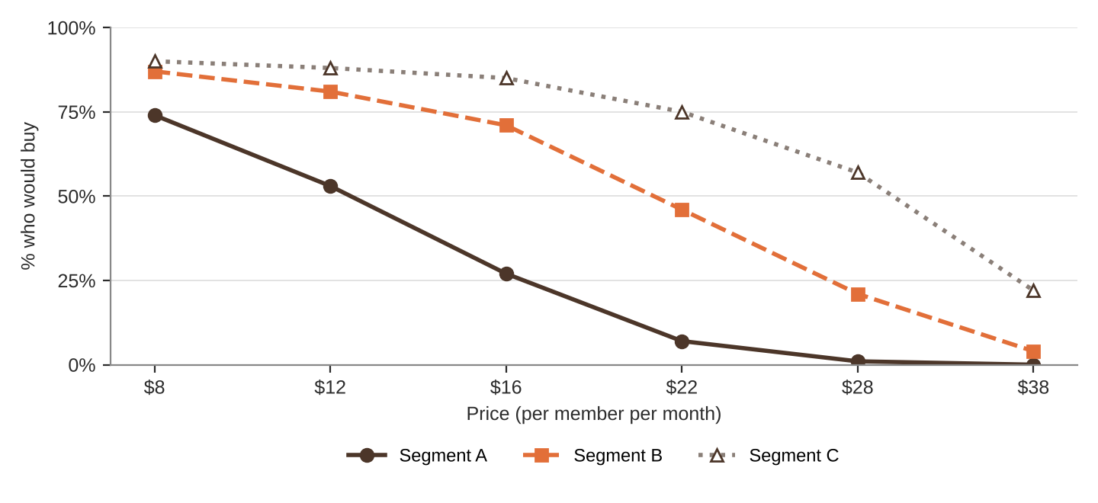
% of each segment who would buy at each price
Price | $8 | $12 | $16 | $22 | $28 | $38
Segment A | 74% | 53% | 27% | 7% | 1% | 0%
Segment B | 87% | 81% | 71% | 46% | 21% | 4%
Segment C | 90% | 88% | 85% | 75% | 57% | 22%
QUICK RULES
Must-have | A feature that 60% or more of a segment requires. Leave one out and that segment's buyers are cut in half. Leave two out and they're cut in half again.
Nice-to-have | A feature that 30% to 59% of a segment requires. Each one you include adds 5% to Fit.
Under 30% | That segment doesn't care. It adds cost and nothing else.
Fit | Start at 100%. Add 5% for each nice-to-have included. Then cut in half for each must-have left out.
Buyers | Segment size × % who would buy at your price × Fit. Round to a whole number.
Profit | Buyers × (Price − Unit cost). Unit cost = base cost + cost of every feature you added.

